|  |
| --- |
|  |

**Provide a report on your findings from the pcap file and outline what processes / the steps you followed to achieve this. Here are each of your sub-tasks with additional instructions. Please record your findings under each sub-task title.**

**Packet Capture Analysis:**

I have analysed the provided packet capture file using the free network analysis tool Wireshark.   
I was able to put “http” into the filter field in order to filter the network traffic to only see HTTP packets.   
  
This view let me see some interesting http GET requests, which indicate that the user specifically requests information.

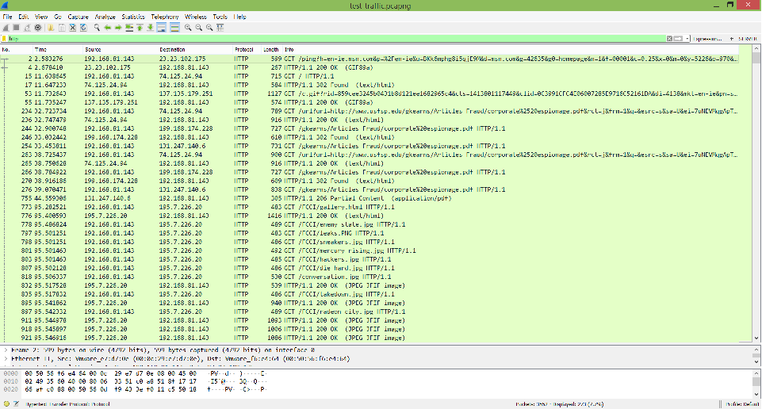

To investigate this image download further, I viewed its TCP stream to see what I could find.  
Looking through the data in the TCP stream showed that this get request actually downloaded two images, as the data contained two headers and two footers for a .jpg image. The header/footer is FFD8 – FFD9 in hex and the images are also recognizable in ASCII by the string ‘JFIF’ near the start.

**Sub-task 1:**

* *anz-logo.jpg and bank-card.jpg are two images that show up in the users network traffic.*
* 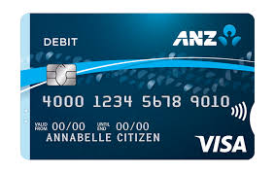
* *Extract these images from the pcap file and attach them to your report.*

**Sub-task 2:**

* *The network traffic for the images "ANZ1.jpg" and "ANZ2.jpg" is more than it appears.*
* 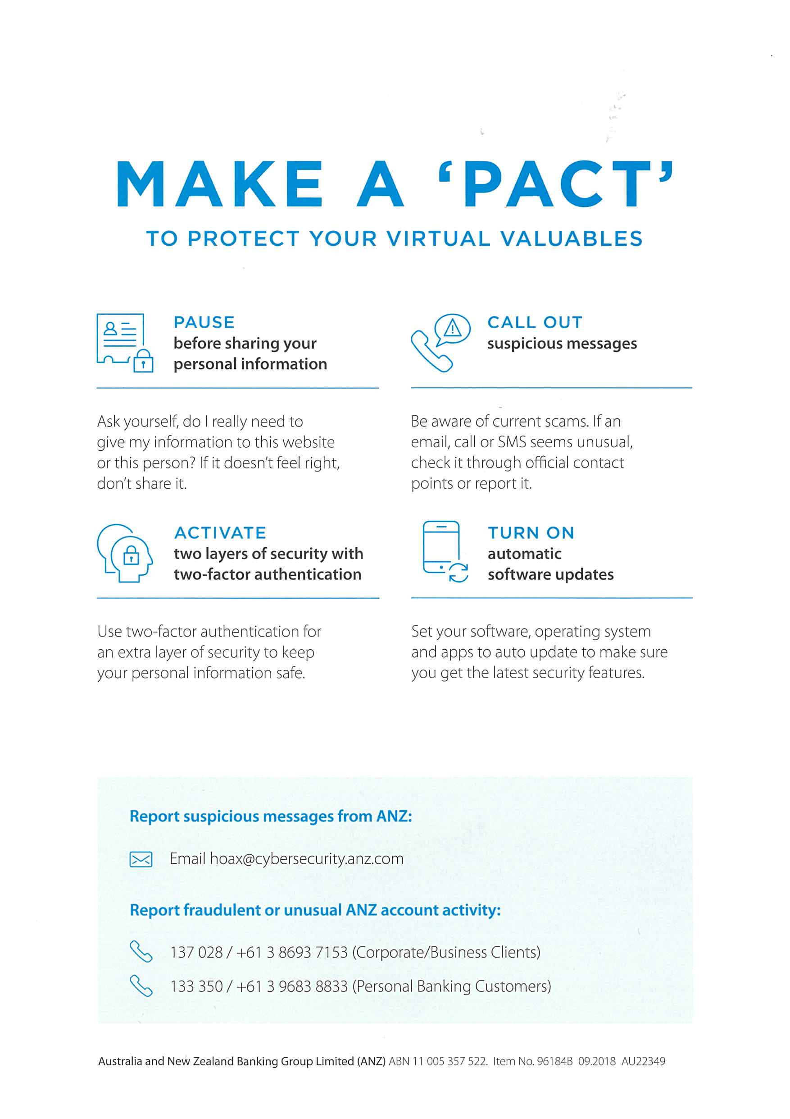
* *Extract the images, include them and mention what is different about them in your report.*

**Sub-task 3:**

* *The user downloaded a suspicious document called "how-to-commit-crimes.docx"*
* *Find the contents of this file and include it in your report.*

*Contents of file :*

Step 1: Find target

Step 2: Hack them

This is a suspicious document.

**Sub-task 4:**

* *The user accessed 3 pdf documents: ANZ_Document.pdf, ANZ_Document2.pdf, evil.pdf*
* *Extract and view these documents. Include images of them in your report.*

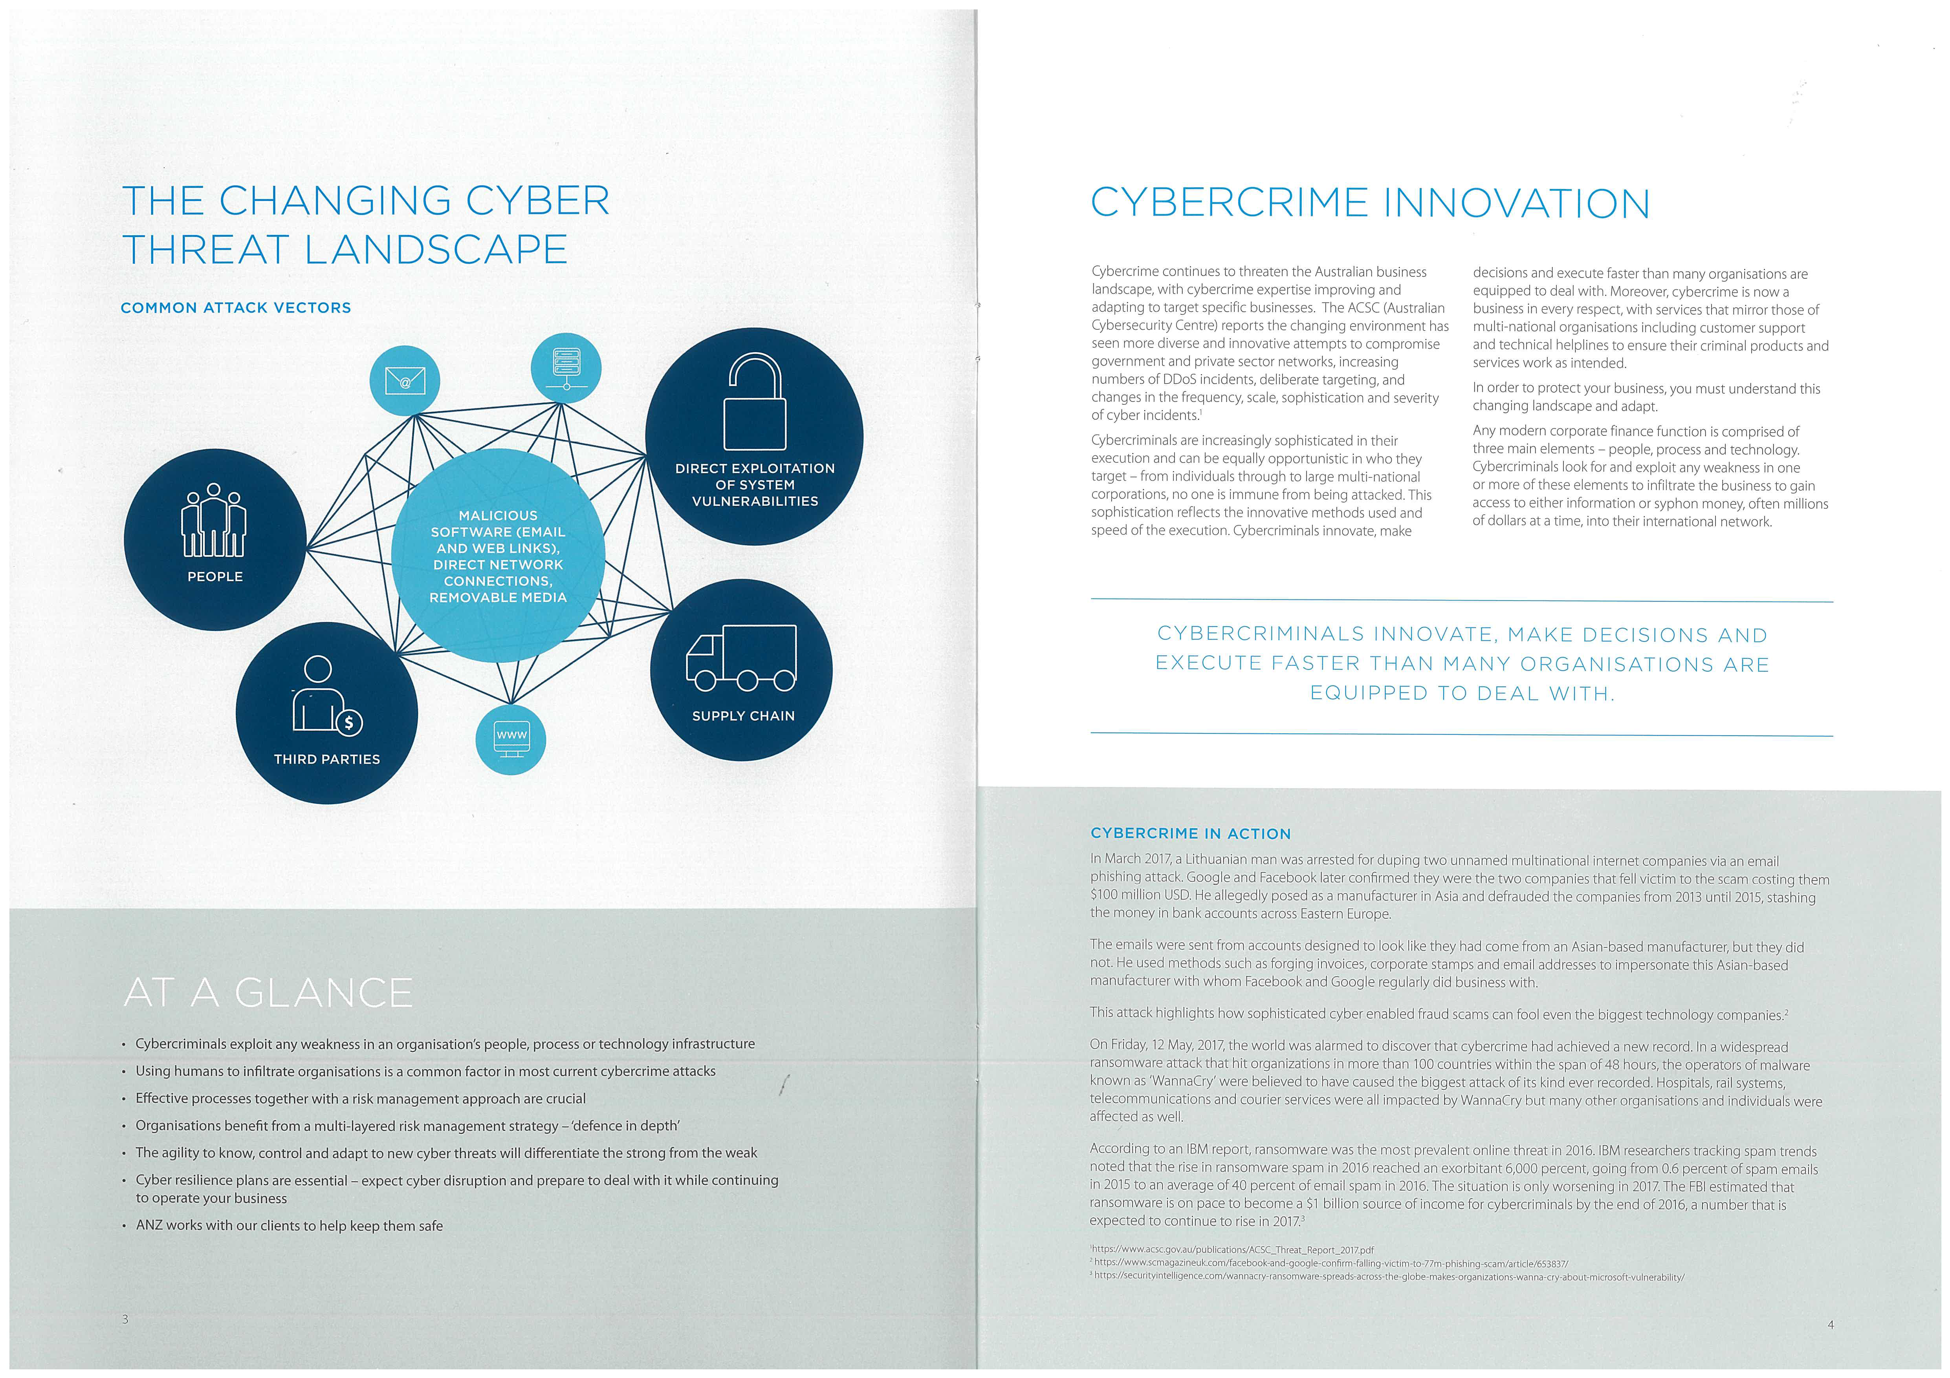



**Sub-task 5:**

* *The user also accessed a file called "hiddenmessage2.txt"*
* *What is the contents of this file? Include it in your report*



**Sub-task 6:**

* *The user accessed an image called "atm-image.jpg"*
* *Identify what is different about this traffic and include everything in your report.*
* 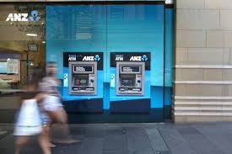

**Sub-task 7:**

* *The network traffic shows that the user accessed the image "broken.png"*
* *Extract and include the image in your report.*
* *Ans: It was encoded in base64 form . So, I used online base64 to image extractor and got following image.*
* **

**Sub-task 8:**

* *The user accessed one more document called securepdf.pdf*
* *Access this document include an image of the pdf in your report. Detail the steps to access it.*
* *It was a password protected file with password : “secure” and was zipped inside zip.*

